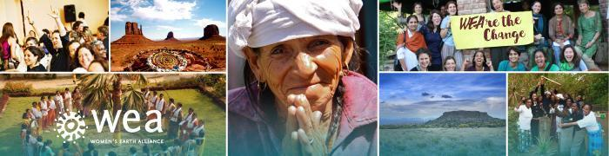

**Global Program Communications Internship**

**Who We Are:**

Women’s Earth Alliance (WEA) is a global organization on a mission to empower women’s leadership to protect our environment, end the climate crisis, and ensure a just, thriving world. We are dedicated to fortifying and dispersing grassroots solutions generated from the heart of communities — where people are grappling with our gravest challenges and drawing blueprints for a thriving future. Since 2006, WEA has trained and funded more than 53,000 women leading environmental initiatives in 31 countries, who have reached 24+ million people with life-saving climate solutions.

Through partnerships with locally-led Program Lead organizations, WEA co-designs impactful Accelerators and trainings tailored to regional and sector-specific needs. These programs offer cohorts of women leaders capacity-building, seed funding, and mentorship, helping them catalyze their solutions and share knowledge across regions. WEA’s programs focus on key areas, including: Regenerative Agriculture and Food Systems; Conservation and Ecosystem Stewardship; Sustainable Livelihoods; Clean Energy Access and Advocacy; Health and Wellbeing; and Indigenous Knowledge.

**The Internship:**

The purpose of this educational internship is for Global Program Communications Interns to learn about nonprofit communications, digital learning design, and visual storytelling in the context of global grassroots climate and gender justice programs. Interns will gain hands-on experience in how communications and program teams collaborate to design resources, share stories, and create accessible online learning tools.

The Global Program Communications Intern will:

* Learn how to **design and edit creative materials and assets** for global training programs, learning toolkits, and fundraising and awareness campaigns.
* Learn foundational **nonprofit branding principles**, as well as basic **design and editing** skills using Canva and, when possible, Adobe Creative Suite tools.
* Learn tools, strategies and best practices for **organizing and managing program communications and digital learning resources** to ensure consistency, accessibility, and long-term use across global initiatives.
* Learn to **develop holistic online learning modules**—including content creation, organization, tracking, and ongoing management—designed to support and accelerate women’s environmental leadership.

**Skills You Will Gain:**

Interns will broaden and/or gain skills in nonprofit program communications and digital learning:

* **Team Collaboration:** Understanding how communications and program teams work together to advance shared goals (Slack, Google Docs).
* **Systems Management**: Building tools and systems that help teams track and manage communications and learning projects (Airtable, Google Sheets).
* **Curriculum Creation:** Learning what goes into designing and delivering skill-based educational content for a global alliance.
* **Platform Management:** Gaining experience with online learning platforms (Teachable), including editing, formatting, and curating content for community learning.
* **Design & Editing:** Developing skills in visual design and content editing, from graphics and decks to multimedia formatting (Canva, Adobe Creative Suite).

**The Ideal Intern:**

* Has a strong interest in gender, climate, and environmental justice.
* Is meticulous, organized and enjoys working within creative guidelines.
* Is familiar with digital design tools (Canva is ideal; Adobe Illustrator/Photoshop a plus).
* Is comfortable navigating digital platforms (Google Drive and Zoom are ideal; Teachable a plus).
* Has strong writing and verbal communication skills.
* Is proactive and able to manage multiple deadlines.
* Thrives in a remote, collaborative environment and values teamwork.

**Commitment:**

This internship is expected to last at least 4 months—though we love it when awesome people want to stay and be awesome for longer, so let us know if you’re available for a longer opportunity. Interns must be available 10-15 hours a week.

All our internships are remote.

**Compensation:**

Interns receive a $2,000 stipend for 4 months. This is a unique opportunity to be part of and grow with a small women-led organization with a large, global impact. We are also happy to work with interns hoping to receive academic credit for their time with us.

**To Apply:**

To apply, please go to Join our Team on our website [https://womensearthalliance.org/about-us/join-our-team/] to submit your application. WEA welcomes interns from diverse gender, educational, socio-economic, racial and cultural backgrounds.

*Women’s Earth Alliance is a fiscal sponsored project of Earth Island Institute.*